2. Hive + Parquet

in S3.
Database: <user_id>_airlines
Database: <user_id>_airlines_raw
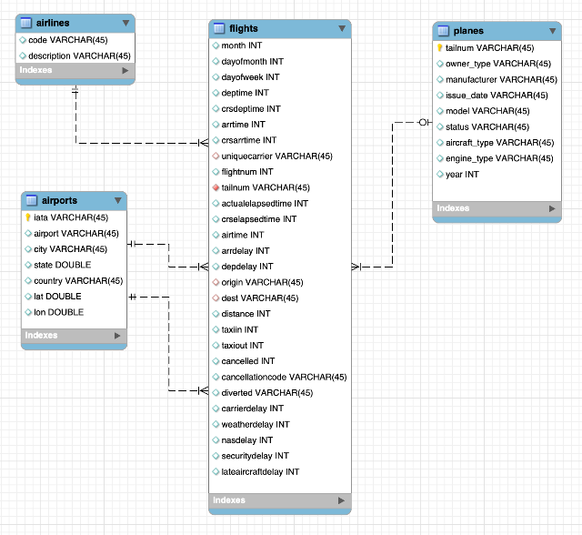
5b. In-Place migration

in S3.
6. Iceberg Table (Parquet + Partition) + Data Load

in S3.
4. Hive ACID

in S3.
3. Hive + ORC

in S3.
5a. Iceberg Table + CTAS

in S3.
1. All tables stored as CSV files in S3.

in S3.

